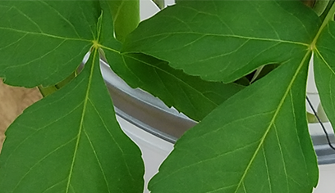
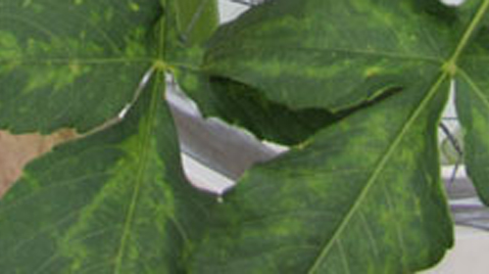
Key Strategies for Improving Dahlia Health
A small set of consistent management practices can substantially improve dahlia health and reduce virus spread.
Risk-Based Separation
Assign dahlias to distinct planting areas based on their likelihood of infection. Symptomatic plants and unobserved new stock carry the highest risk. Asymptomatic, untested plants are at moderate risk. First-year seedlings and tested plants that remain asymptomatic have the lowest risk. Maintain as much physical separation between these groups as possible.
Sanitation
Always disinfect tools between plants while working in the garden. Rotating and immersing blades in a 10% bleach solution for at least one minute between plants reduces mechanical virus transmission.
Pest Management
Implement early, consistent aphid and thrip control strategies to reduce virus transmission by insect vectors.
Symptom Monitoring
Become familiar with common virus symptoms, including yellowing veins, necrotic spotting, slow growth, weak stems, and short internodes. Remove symptomatic plants from low- or moderate-risk beds promptly.
Low-Risk Stock Development
Start dahlias from seed, which is the most economical beginning to virus-free plants. Seek new stock from growers who offer virus-tested dahlias or follow practices that minimize disease transmission. Propagate dahlias from plants in your low-risk group.
These steps, when used consistently and year-over-year, have been shown to markedly improve dahlia health.
Extracted from: “Growing Healthier Dahlias: Lessons from Pioneering Growers,” by Janell Weiss, LeeAnn Huber, Beckie Curtis and Ron Miner, ADS Bulletin, April, 2026. Copyright American Dahlia Society. All rights reserved. But please feel free to copy and share with others

