ADS SHOW REGISTRATION
American Dahlia Society 53rd National and Midwest Conference Show
Hosted by the WEST MICHIGAN DAHLIA SOCIETY
AT FREDERIK MEIJER GARDENS, Grand Rapids, Michigan
August 29 – September 1, 2019

Registrant #1 Name ________________________________________________________________

Registrant #2 Name ________________________________________________________________

Address __________________________________________________________________________

City _____________________________State/Province _____________________ Zip____________

Phone _________________________________ Email ____________________________________

Home Dahlia Society ________________________________________________________________

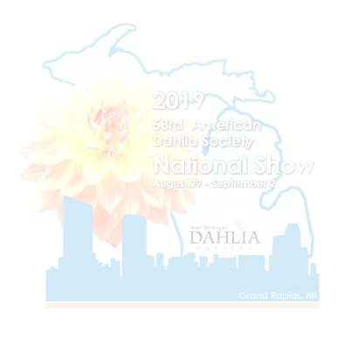
FULL REGISTRATION includes: Show Registration, Saturday lunch, admission to the Frederik Meijer Gardens with Tram ride tour, seminars and Saturday night banquet.

$150.00 (US) per person by August 1, 2019 Number _____ x $ _______ = $_____________

$170.00 (US) per person after August 1, 2019 Number_____x $________ = $_____________
Sorry we cannot offer partial registrations.
Tours: Minimum of 25 paid registrants required.
1. Friday Tour with boxed lunch $50.00 x number ___________ = $ ______________

$
-Three Acre Farm, Huff Park, Grand Lady Riverboat Cruise
Please check one entrée selection for each registrant.
Dinners come with salad, rolls, coffee & dessert | Registration #1 | Registration #2
Chicken Saltimbocca, chicken breast with sage wrapped prosciutto, roasted garlic demi, served with roasted marble potatoes & steamed asparagus
Pecan-Crusted Maple Salmon, fresh salmon glazed with BLIS (sic) bourbon maple syrup and topped with crushed pecans. Served with soft heirloom corn polenta and sautéed haricot verts.
Parisian Gnocchi (V) Handmade French gnocchi, cremini mushrooms, asparagus, red and yellow cherry tomato confit, sage brown butter, sea salt. (vegetarian)
Special dietary needs? Please specify: | Gluten free | Veg

When do you plan to arrive? Thurs_____ Fri_____ Sat______

EXHIBITOR, JUDGE, AND CLERK INFORMATION
EXHIBITORS
Exhibiting blooms? Yes___ No___ Approx. # _____ Class: Novice ___ Small ___ Middle___ Large____

Will you bring ADS seedlings to be scored on the bench? Yes _______No _______ Approx. #_______

Will you exhibit in Artistic Design? Pre-registration required. Yes _______No _______

Contact: Kathy Stevenson, 616-299-8182 or kastevenson2@aol.com Registration closes 8/25/19.

Number entries: Class 1_____ Class 2_____ Class 3_____ Class 4____ Class 5____ Class 6____

Do you want entry tags mailed to you? Yes________ No _______ Number _______
JUDGES Will you judge? Yes_____ No_____
1st. Judge’s Name ______________________________Senior____ Accredited ____Candidate ____

2nd Judge’s Name ______________________________Senior ____ Accredited ____Candidate ____

CLERKS Will you clerk? Yes_____ No_____
1st Clerk’s Name _____________________________________________________________________

2nd Clerk’s Name _____________________________________________________________________
Will you be touring the Frederik Meijer Gardens? (included) Yes ⇨ No ⇨ How many? ___________
Guided tour of Japanese garden ⇨ Saturday 2:00 p.m. 45 min walking tour.
Do you have a reciprocal garden pass that will allow you to get in for free? Yes ⇨ No ⇨
Unsure? Check this link: https://www.ahsgardening.org/gardening-programs/rap/find/statebystate
You will need to bring this pass with you to the FMG registration desk.
Send your completed registration and exhibitor/ judge/ clerk information forms along with a check/money order (US funds) made payable to: “WMDS” or West Michigan Dahlia Society to:

Lil Eitniear, Treasurer
W.M.D.S. Show
7781 E. Grant Rd.
Hesperia, Michigan 49421
Email questions to: wmds2019show@gmail.com or call Joanne Jepsen, WMDS Show Chairman at
616-915-2806 or email jojrn@aol.com Check for updated information, including show program when available, at www.westmidahlia.com
* Your name badge will be your proof of payment and allow entrance to the gardens and tours. Please wear it at all times.

